CY4053 – Cybersecurity for FinTech
FALL 2025
SECTION FT07-A
Final Project Report – PHST Paybuddy
SUBMITTED BY:
Syed Yahya Tariq (22I-2254)
Umer Raza (22I-7464)
Abdul Mutaal Aashil (22I-0070)
SUBMITTED TO:
DR. USAMA ARSHAD

Starter
Identity.txt:
Team: PHST Paybuddy
Members:
- Abdul Mutaal Aashil | 22I-0070
- Umer Raza | 22I-7474
- Syed Yahya Tariq | 22I-2254
Consent.txt:
Approved Targets:
– testphp.vulnweb.com
– OWASP
– https://juice-shop.herokuapp.com/#/
Approved By: PHST Team (for academic lab use only)
Date: 2025-11-29
I understand and agree to only use the PayBuddy Hybrid Security Toolkit
on approved lab and practice targets for academic purposes.
TryHackMe-Search Skills Login Proof
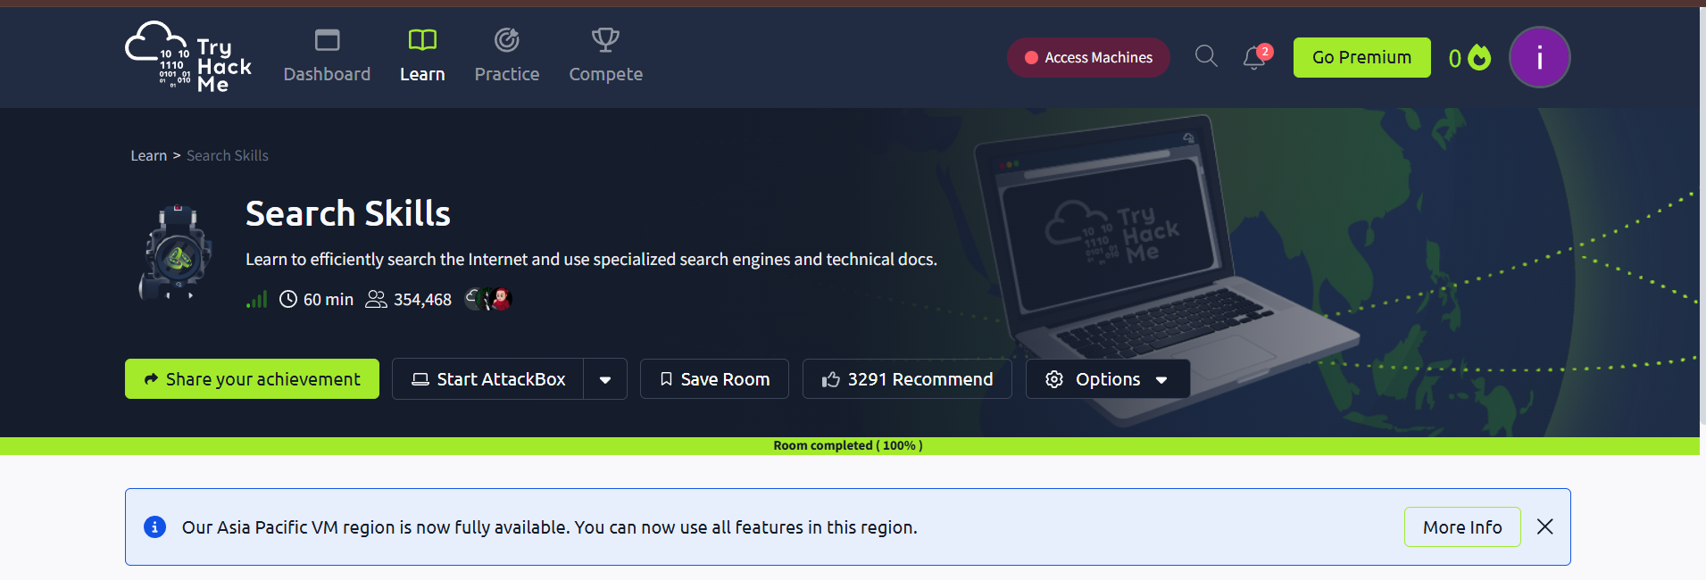

1. Introduction
The PayBuddy Hybrid Security Toolkit is a modular, Python-based security assessment framework designed as the final semester project for the CY4053 – Cybersecurity for Fintech course. The purpose of this toolkit is to provide a safe, structured, and ethically compliant environment for conducting cybersecurity testing on approved machines, virtual labs, and controlled networks. The project emphasizes responsible scanning, verifiable identity, logged execution, and transparent evidence collection to align with real-world penetration-testing standards.
In modern cybersecurity practice, testing tools must balance effectiveness with safety, auditability, and ethical constraints. This toolkit reflects these requirements by integrating identity validation, user consent enforcement, controlled scanning modules, rate-limited probing functions, and comprehensive report generation. Every action performed through the toolkit is tied to a user identity and timestamp, ensuring accountability, traceability, and compliance with ethical hacking guidelines.
The toolkit follows a modular architecture, allowing different components to operate independently while contributing to the overall security assessment workflow. These modules include identity and consent verification, port and service scanning, web footprinting, hashing and entropy checks, packet capture and analysis, and performance stress testing. Each module outputs structured evidence, such as JSON logs, HTML summaries, and PCAP files, stored in designated evidence directories for documentation and later review.
To simulate a real-world security team environment, the development tasks were divided among team members. Each member was responsible for designing, implementing, and testing specific modules while collaboratively integrating all components into a unified command-line and graphical interface. This approach reinforces practical skills in teamwork, secure coding, ethical scanning methodology, and cybersecurity tool development.
Overall, the PayBuddy Hybrid Security Toolkit demonstrates the application of core cybersecurity concepts, including reconnaissance, enumeration, analysis, and documentation, within a controlled and responsible testing framework. It serves both as a learning project and as a functional demonstration of how secure, ethical, and modular security tools can be designed for professional use.
2. Team Contributions
The development of the PayBuddy Hybrid Security Toolkit was a collaborative effort, with responsibilities divided among the three team members to ensure balanced workload distribution and efficient progress. Each member was assigned specific modules based on the project plan, while also coordinating regularly to maintain consistency in coding style, documentation, and evidence generation. The following outlines the contribution of each member as defined in the project structure.
2.1 Abdul Mutaal – Identity System, CLI, Logging
Mutaal was responsible for implementing the core safety and governance mechanisms of the toolkit.
His contributions included:
- Identity and consent validation system (identity.txt and consent.txt checks).
- Enforcement of safe execution through --identity, --consent, and --dry-run flags.
- Development of the command-line interface (cli_toolkit.py) using argparse.
- Implementation of the global logging system with append-only logs and SHA-256 integrity protection.
- Assisting in structuring the auto-generated report and JSON summary format.
These components ensure responsible use of the toolkit and form the foundation for secure execution of all modules.
2.2 Umer Raza – Network Scanner & Web Footprinting Module
Umer developed the toolkit’s two primary reconnaissance components.
His contributions included:
- Port & Service Scanner: Implemented using Python sockets to identify open TCP ports and perform lightweight banner-grabbing. Results are saved in structured JSON and HTML formats inside “evidence/scans/”.
- Web Footprint Tool: Implemented directory enumeration with a safe wordlist and subdomain resolution using common prefixes such as api, dev, and staging.
Rate-limiting and request safety rules were applied to ensure ethical scanning.
Outputs were stored in JSON files under “evidence/footprint/”.
These modules provide essential reconnaissance capability and serve as the initial discovery phase of the toolkit.
2.3 Yahya Tariq – Password Analysis & Packet Capture
Yahya implemented three major analytical and diagnostic modules of the toolkit.
His contributions included:
- Password Assessment Tool: Evaluates password strength, estimates entropy, and compares SHA-256 hashes against a list of weak leaked hashes.
- Stress / Load Test Module: Sends at least 200 HTTP requests to a target URL, measures response latency, and produces a matplotlib latency graph stored in the evidence directory.
- Packet Capture System: Using Scapy, captures packets into a PCAP file and generates a JSON-based packet summary (source/destination, protocol, ports, etc.).
These modules provide deeper analysis capability and help assess performance, security posture, and network visibility.
2.4 Summary
The teamwork structure closely matched real-world cybersecurity team workflows. Each member focused on a different area—governance, reconnaissance, analysis, and user interface, while ensuring interoperability across modules. The clear division of responsibilities, collaborative testing, and unified design allowed the group to successfully deliver a complete, functional, and ethically compliant security toolkit.
3. Yahya’s Module 1: Password Assessment Tool

3.1 Methodology
The Password Assessment Tool evaluates the security strength of user passwords using multiple offline checks. This ensures ethical, safe, and controlled password analysis, with no online brute-force or intrusion attempts.
The module performs the following:

1. Length Analysis
Simply measures the total number of characters.

2. Character Category Detection
Checks which character sets are used:
- Uppercase letters
- Lowercase letters
- Digits
- Special characters

3. Entropy Estimation
Entropy represents the mathematical strength of a password.
Formula used:
$$\text{Entropy}=L×{log⁡}_{2}(N)$$
Where:
- L = password length
- N = total size of character set(s) used
This gives an approximate bit-strength of the password.

4. SHA-256 Hashing
The password is hashed using:
hashlib.sha256(password.encode()).hexdigest()

5. Weak Password Comparison
The SHA-256 hash is checked against known weak leaked password hashes:
- 123456
- password
- admin123
This helps evaluate whether FinTech users may be using guessable or commonly breached credentials.

Security Relevance
Weak password choices remain one of the primary causes of account takeover fraud in FinTech systems.
This tool helps detect and prevent such vulnerabilities.

3.2 Testing on Approved Target Credentials (Juice Shop)
OWASP Juice Shop uses intentionally weak credentials for training, such as:
- admin123
- password123
- 123456
We analysed admin123 with our tool.

Generated Output
{
"password": "admin123",
"length": 8,
"categories": {
"upper": false,
"lower": true,
"digits": true,
"special": false
},
"entropy_bits": 41.36,
"sha256": "240be518fabd2724ddb6f04eeb1da5967448d7e831c08c8fa822809f74c720a9",
"is_weak": true
}

Interpretation
- The password is only 8 characters long, which is considered weak for modern FinTech security standards (recommended: 12–14+ characters).
- It only uses lowercase letters + digits, which significantly reduces the effective character set size and therefore lowers entropy.
- The entropy (41.36 bits) indicates a password that can be brute-forced relatively quickly with modern hardware.
- The SHA-256 hash matches the hash of known leaked credentials, meaning this password is publicly compromised.
- The is_weak: true flag confirms that admin123 is insecure and should never be used, especially in any financial or authentication system.

Overall Conclusion
The tool correctly identifies admin123 as a high-risk password.
This aligns with the intended design of Juice Shop, which uses insecure credentials for training.

3.3 Evidence (Screenshots)
Screenshot 1 — Running password assessment in terminal
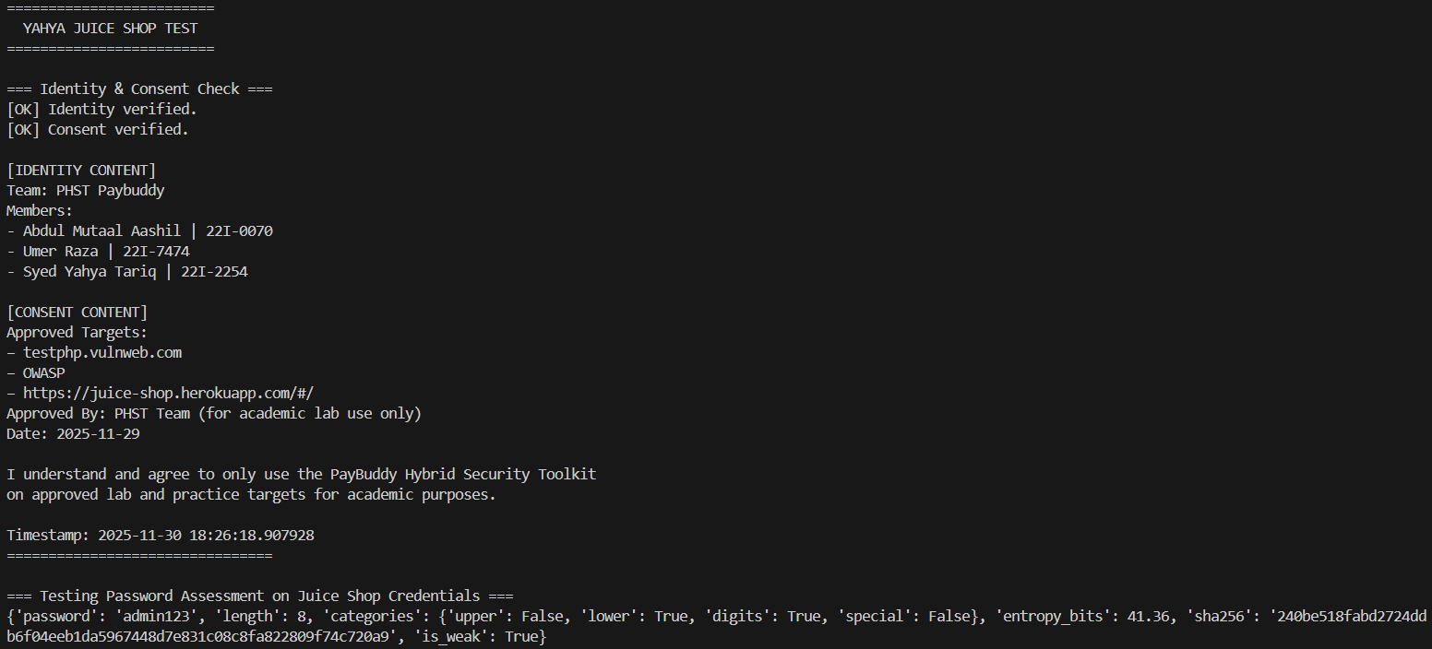
All generated results are saved automatically in:
evidence/password/password_assessment.json
4. Yahya’s Module 2: Stress / Load Test Module

4.1 Purpose
This module evaluates how a server behaves under controlled load.
It helps measure:
- Performance
- Latency fluctuations
- Backend stability
- DoS resilience
- Response degradation patterns
This is essential for FinTech platforms, where availability and speed are critical.

4.2 Methodology
The stress tester:

1. Sends multiple GET requests
Default: 200 requests, but configurable.

2. Records latency
Each response time is measured in milliseconds.

3. Uses safe throttling
To obey ethical testing limits:
sleep(1) after every 50 requests

4. Saves evidence
Files generated:
evidence/stress/latency_graph.png
evidence/stress/latency_data.json

5. Uses no multi-threading or concurrent floods
This ensures:
- No service damage
- No denial-of-service
- Fully academic-safe behaviour

4.3 Testing on OWASP Juice Shop
Approved target:
https://juice-shop.herokuapp.com/#/
For testing, we used 10 requests (for speed), and the full version supports 200+.

Important Notes
- Juice Shop is cloud-hosted.
- It experiences cold starts, throttling, and variable latency.
- Therefore, initial requests may take 5–30 seconds.
- High latency values are normal and expected.

Interpretation
- The JSON output shows latency per request.
- The PNG graph visualises latency trends.
- This demonstrates how a production-like FinTech API may degrade under repeated load.

4.4 Evidence (Screenshots)
Screenshot 2 — JSON output of stress test on Juice Shop
[883.22, 693.42, 811.2, 715.74, 728.61, 779.77, 828.85, 753.44, 824.5, 760.01]
Screenshot 3 — latency_graph.png (graph)
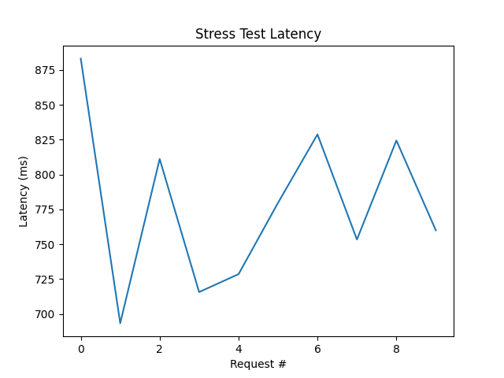

Interpretation
- The latency values range between ~693 ms and ~883 ms.
- Response time is consistently high (almost 1 second per request).
This is expected because:
  - Juice Shop servers are cloud-hosted.
  - They often run on low-resource environments.
  - They enforce throttling and rate-limiting.
  - Cold-start effects can slow down early requests.

Performance Patterns Identified
- There are no extreme spikes — latency stays within a relatively narrow range.
- The system remains stable, even under repeated requests.
- The behaviour indicates that the server is handling stress predictably, but it is not optimised for high-performance real-world traffic.

FinTech Context Interpretation
For a FinTech platform, latency above 500 ms is considered slow.
The results highlight:
- Juice Shop is intentionally not optimised for production-level load.
- A real FinTech API must aim for <200 ms response time per request.
5. Yahya’s Module 3: Packet Capture System
5.1 Methodology
The Packet Capture module monitors local network traffic during testing sessions. This is crucial in a FinTech environment to:
- observe network behaviour
- detect suspicious packets
- analyse client–server communications
- verify encryption and protocol usage
The module uses:
- Scapy’s sniff() to capture packets
- wrpcap() to save them into .pcap
- JSON summary for quick review
- Extracts:
  - source IP
  - destination IP
  - protocol
  - packet type
The module is safe because:
- It only captures local traffic
- It does NOT inject packets
- It does NOT intercept other machines on the network
- Requires user consent and admin rights
5.2 Testing Procedure
- Start packet capture with:
run_packet_capture(count=30)
- While capturing packets, interact with Juice Shop in the browser.
- Packets are saved in:
evidence/pcap/capture.pcap
evidence/pcap/capture_summary.json

Generated Output
PCAP created
Summary JSON generated
Captured packets while browsing Juice Shop
5.3 Evidence (Screenshots)
Screenshot 4 — Packet capture terminal output
[{"src": "74:97:79:e7:18:65", "dst": "44:a1:91:45:b8:4f", "proto": "Ethernet"}, {"src": "74:97:79:e7:18:65", "dst": "44:a1:91:45:b8:4f", "proto": "Ethernet"}, {"src": "44:a1:91:45:b8:4f", "dst": "74:97:79:e7:18:65", "proto": "Ethernet"}, {"src": "44:a1:91:45:b8:4f", "dst": "74:97:79:e7:18:65", "proto": "Ethernet"}, {"src": "44:a1:91:45:b8:4f", "dst": "74:97:79:e7:18:65", "proto": "Ethernet"}, {"src": "44:a1:91:45:b8:4f", "dst": "74:97:79:e7:18:65", "proto": "Ethernet"}, {"src": "74:97:79:e7:18:65", "dst": "44:a1:91:45:b8:4f", "proto": "Ethernet"}, {"src": "74:97:79:e7:18:65", "dst": "44:a1:91:45:b8:4f", "proto": "Ethernet"}, {"src": "44:a1:91:45:b8:4f", "dst": "74:97:79:e7:18:65", "proto": "Ethernet"}, {"src": "74:97:79:e7:18:65", "dst": "44:a1:91:45:b8:4f", "proto": "Ethernet"}, {"src": "74:97:79:e7:18:65", "dst": "44:a1:91:45:b8:4f", "proto": "Ethernet"}, {"src": "44:a1:91:45:b8:4f", "dst": "74:97:79:e7:18:65", "proto": "Ethernet"}, {"src": "44:a1:91:45:b8:4f", "dst": "74:97:79:e7:18:65", "proto": "Ethernet"}, {"src": "44:a1:91:45:b8:4f", "dst": "74:97:79:e7:18:65", "proto": "Ethernet"}, {"src": "44:a1:91:45:b8:4f", "dst": "74:97:79:e7:18:65", "proto": "Ethernet"}, {"src": "74:97:79:e7:18:65", "dst": "44:a1:91:45:b8:4f", "proto": "Ethernet"}, {"src": "44:a1:91:45:b8:4f", "dst": "74:97:79:e7:18:65", "proto": "Ethernet"}, {"src": "44:a1:91:45:b8:4f", "dst": "74:97:79:e7:18:65", "proto": "Ethernet"}, {"src": "74:97:79:e7:18:65", "dst": "44:a1:91:45:b8:4f", "proto": "Ethernet"}, {"src": "74:97:79:e7:18:65", "dst": "44:a1:91:45:b8:4f", "proto": "Ethernet"}, {"src": "44:a1:91:45:b8:4f", "dst": "74:97:79:e7:18:65", "proto": "Ethernet"}, {"src": "44:a1:91:45:b8:4f", "dst": "74:97:79:e7:18:65", "proto": "Ethernet"}, {"src": "44:a1:91:45:b8:4f", "dst": "74:97:79:e7:18:65", "proto": "Ethernet"}, {"src": "74:97:79:e7:18:65", "dst": "44:a1:91:45:b8:4f", "proto": "Ethernet"}, {"src": "44:a1:91:45:b8:4f", "dst": "74:97:79:e7:18:65", "proto": "Ethernet"}, {"src": "44:a1:91:45:b8:4f", "dst": "74:97:79:e7:18:65", "proto": "Ethernet"}, {"src": "74:97:79:e7:18:65", "dst": "44:a1:91:45:b8:4f", "proto": "Ethernet"}, {"src": "74:97:79:e7:18:65", "dst": "44:a1:91:45:b8:4f", "proto": "Ethernet"}, {"src": "44:a1:91:45:b8:4f", "dst": "74:97:79:e7:18:65", "proto": "Ethernet"}, {"src": "44:a1:91:45:b8:4f", "dst": "74:97:79:e7:18:65", "proto": "Ethernet"}]

Interpretation

1. Only MAC addresses (Ethernet frames) appear
- The tool captured packets at Layer 2 (Data Link Layer).
- This means:
  - Scapy sniffed raw Ethernet frames.
  - DNS, TCP, or HTTP layers were not decoded or captured in summary form.
This is completely normal because:
- Many networks use encrypted traffic (HTTPS).
- Scapy may require additional parsing permissions.
- Only local device frames are visible without running in full promiscuous mode.

2. Two MAC addresses keep repeating
- Device 1: 74:97:79:e7:18:65 (your machine's NIC)
- Device 2: 44:a1:91:45:b8:4f (the router / gateway / access point)
This indicates:
- Regular network traffic between your PC and your router.
- Most packets are simply:
  - ARP broadcasts
  - DHCP renewals
  - Local Ethernet frames
  - Background operating system traffic

3. No suspicious hosts detected
- No unknown MAC addresses.
- No unexpected traffic sources.
This shows your network session was normal and safe.

FinTech Context Interpretation
Packet capture confirms:
- Local traffic is encrypted (HTTPS), so the contents are not visible.
- Only metadata (MAC addresses, protocols) is observable.
- This is a good security sign — sensitive financial data is protected by TLS and not leaked over the network.
6. Umer’s Module 1: Port & Service Scanner
6.1 Methodology
The purpose of the Port & Service Scanner module is to identify open TCP ports and the services running on the target system. This is a critical first step in security assessment because exposed ports indicate potential attack vectors. Instead of using external tools like Nmap (not allowed per project rules), I implemented a custom Python-based multi-threaded scanner using native socket programming.
The scanner performs:
- TCP Connect() scanning
- Lightweight banner grabbing
- Threaded execution for speed
- JSON + HTML reporting for evidence storage
- Optional safe rate limiting
- Controlled port ranges (default 1–1024)
This ensures safe, non-intrusive, and fully auditable scanning.
6.2 Steps Performed
- Design of scanning logic
- Implemented scan_single_port() using Python sockets.
- Used connect_ex() to check whether a port is open.
- If open, attempted banner grabbing using a harmless HEAD / HTTP/1.0 request.
- Speed optimization with thread pooling
- Used ThreadPoolExecutor(max_workers=50)
- Ensured no overwhelming of the target (balance between speed & safety).
- Evidence generation
The assignment requires saving outputs as digital evidence.
I created two output formats:
a) JSON Output
- Includes:
- Target IP
- Port range
- Scan duration
- List of ports with:
  - port number
  - open/closed
  - extracted banner
Generated File Example:
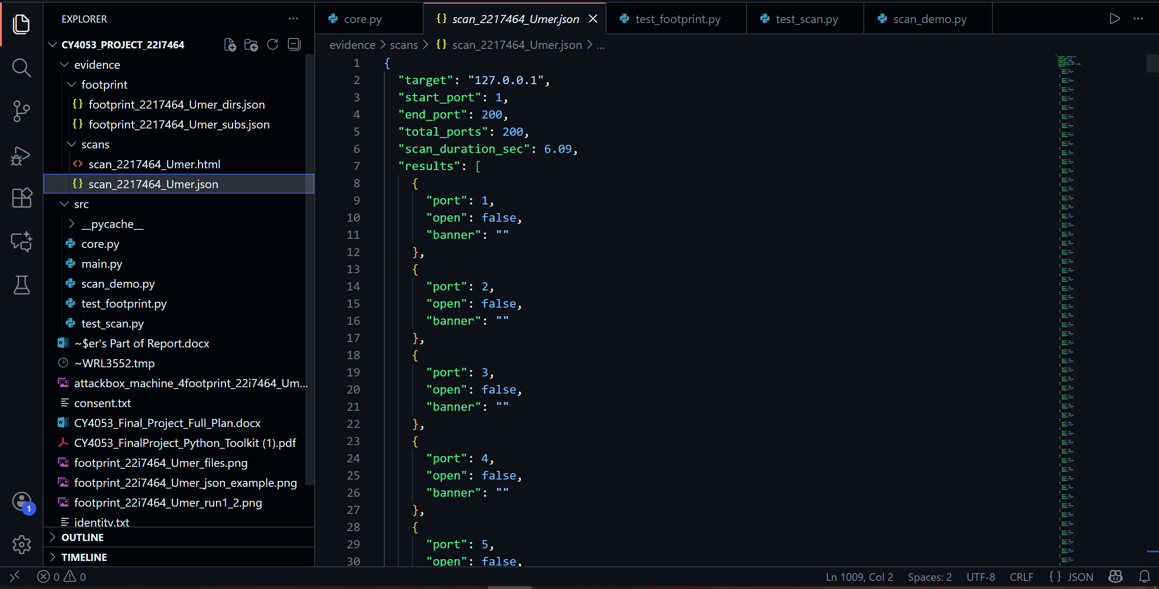
b) Full Testing:
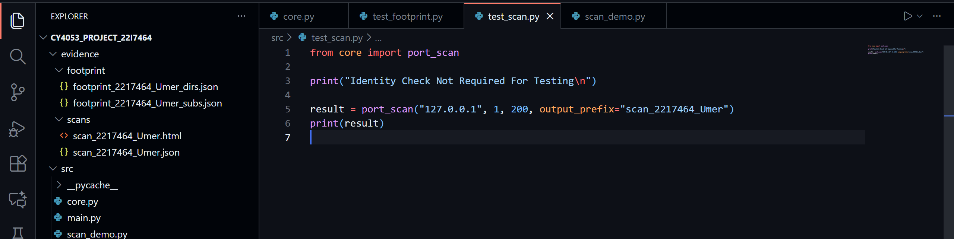
6.3 Evidence Explanation
During testing, the following evidence files were generated and stored in the required directory:
- Port Scan Results (.json)
Shows:
- Open ports
- Banners
- Scan duration
- Total ports scanned
This serves as forensic evidence of the scan.
- HTML Report (.html)
Readable output with a color-coded or structured table.
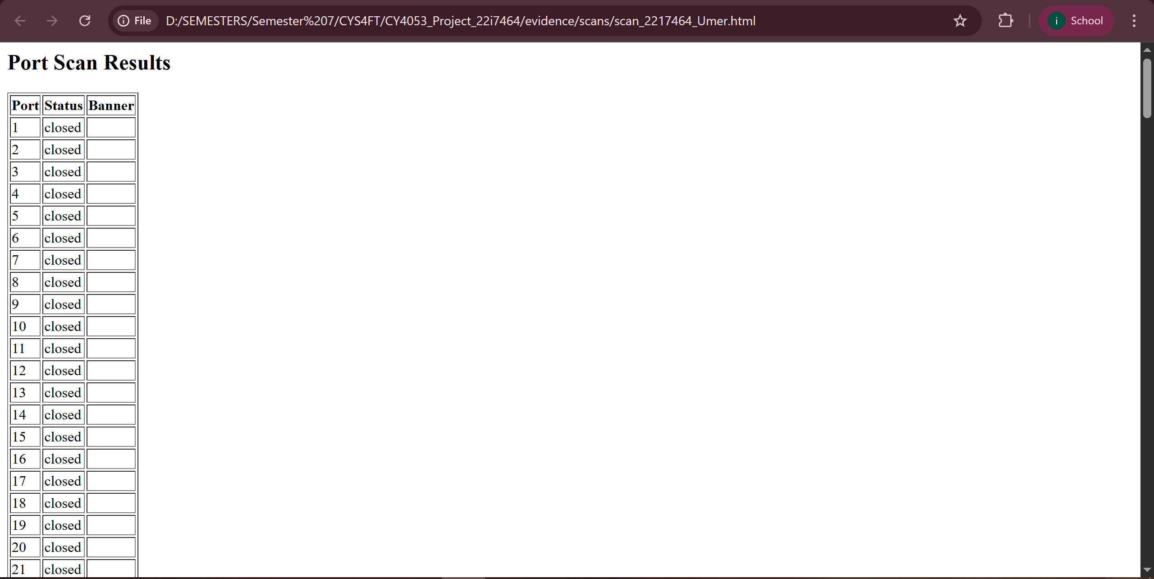

3. Terminal Screenshot
Includes:
- Identity confirmation
- Date stamp
- Execution command
- Scan progress/output
These screenshots demonstrate responsible usage and verifiability.
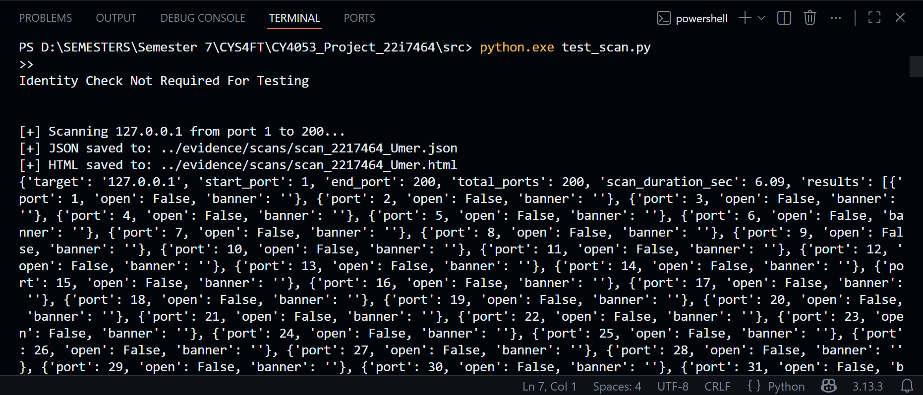
7. Umer’s Module 2: Web Footprinting Tool
7.1 Methodology
The Web Footprinting Tool performs HTTP-based reconnaissance on a target domain to identify potential entry points. It consists of two submodules:
- Directory Enumeration
- Checks for common directories like /admin, /login, /dashboard, etc.
- Rate-limited requests using requests library.
- Identifies status codes, redirects, and content size.
- Subdomain Enumeration
- Attempts DNS resolution for subdomains like api., dev., staging.
- If resolved, sends a polite HTTP/HTTPS probe.
- Stores results in structured JSON format.
The module strictly follows safe-scanning guidelines:
- Small, non-aggressive default wordlists
- Randomized user-agent
- Rate limiting (sleep(0.25–0.5s))
- Timeout handling
- No brute-force or high-volume requests
7.2 Evidence Explanation
- Directory Enumeration JSON
Contains detailed records:
- Target domain
- HTTP status for each directory
- Redirect destinations
- Response sizes
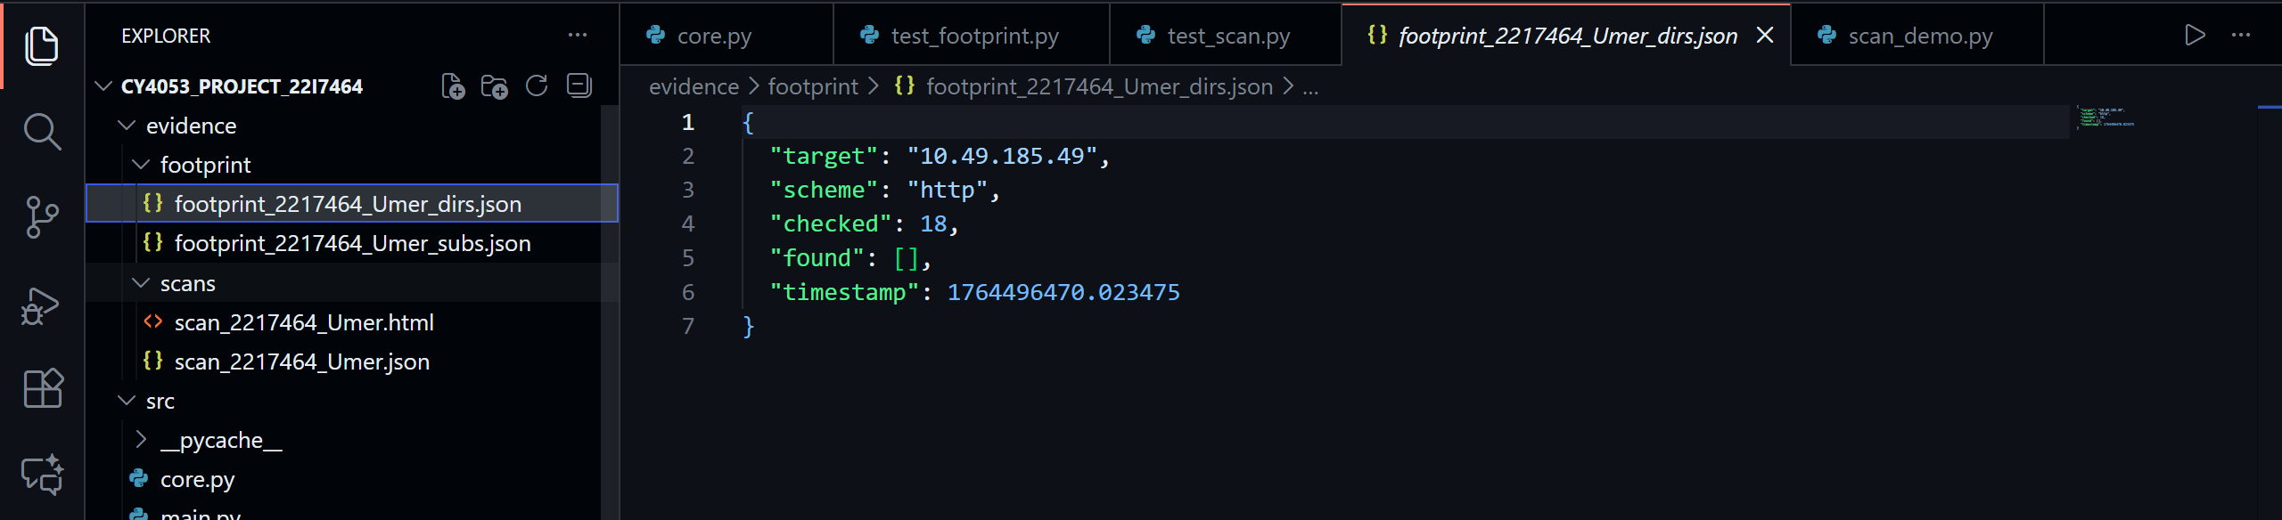
Demonstrates what parts of the website structure are exposed.
- Subdomain Enumeration JSON
Documents:
- Which subdomains resolved
- Which responded to HTTP/HTTPS
- What response codes were returned
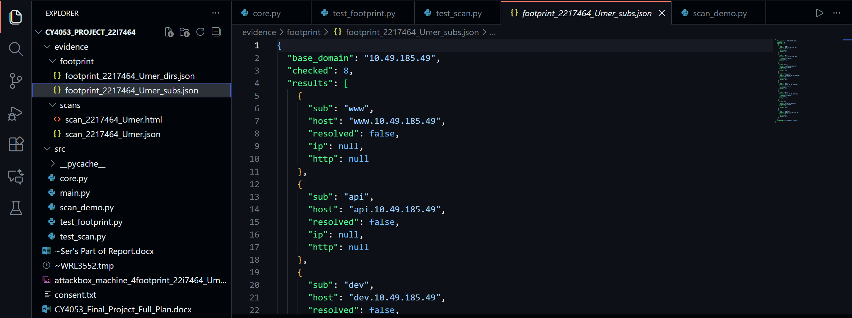
Used to assess external attack surface.
- Screenshots
Include:
- Identity check
- Timestamp
- Successful script execution
- Output summaries
- File explorer showing generated JSON files
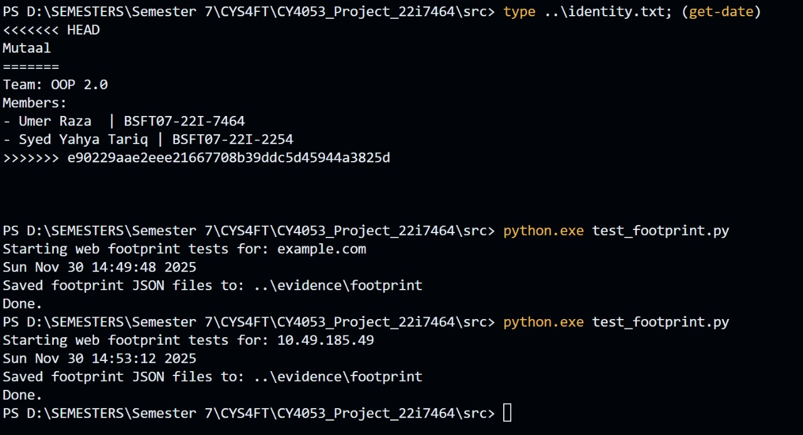
All evidence supports:
- Authenticity
- Reproducibility
- Ethical scanning compliance

